Deployment Instruction Document for Office App

Table of Contents

[**Deployment Instruction Document** 4](#_Toc404802837)

[***Introduction*** 4](#_Toc404802838)

[***Summary*** 4](#_Toc404802839)

[**Deploying Document Storage App** 4](#_Toc404802840)

[***Deploying App Web in the Azure*** 4](#_Toc404802841)

[***Deploying App Manifest in Office*** 5](#_Toc404802842)

[**Creating Accounts for Cloud Storage** 9](#_Toc404802845)

[***Creating and Configuring Dropbox Account*** 9](#_Toc404802846)

[***Creating and Configuring the Google Drive Account*** 12](#_Toc404802847)

[***Creating and Configuring the One Drive Account*** 18](#_Toc404802848)

[***Updating App Web Configuration*** 23](#_Toc404802849)

[***Final Result*** 23](#_Toc404802850)

**Deployment Instruction Document**

***Introduction***

This document describes the instructions required to deploy and configure the task pane app for office 2013. This document also discusses about creating and configuring accounts for Dropbox, Google Drive and OneDrive which will be used in storing documents.

***Summary***

The deployment process is divided into:

1. Deploying Document Storage App
2. Creating Account for Cloud Storage

The first part, “Deploying Document Storage App” needs to deploy the app manifest for office task pane app and deploy App Web on Azure as Azure web site. The second part, “Creating Account for Cloud Storage” covers creating and configuring Dropbox, Google Drive and OneDrive accounts for the Office App.

.

**Deploying Document Storage App**

***Deploying App Web in the Azure***

Followings are steps to Upload App Web on Azure as Azure Website:

1. **Login** to the Azure
2. Go to the **Website Home** where you want to deploy App Web

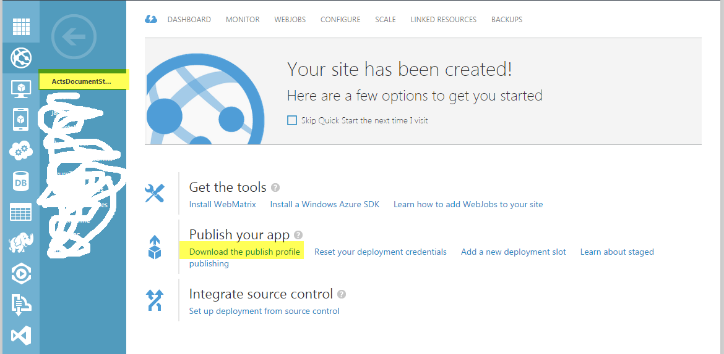

1. **Download the Publish Profile** as described in the below image.
2. **Deploy the App Web** on particular azure using the published profile.

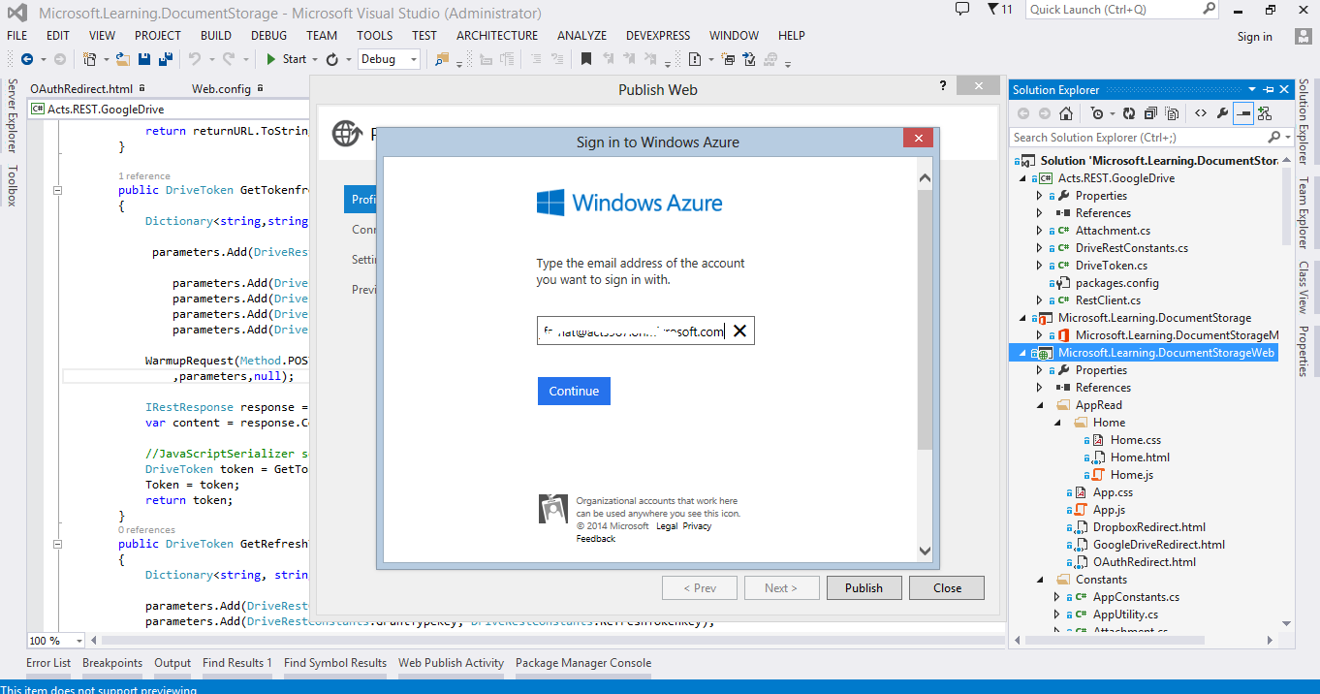

***Deploying App Manifest in Office***

In the first step, we will create App manifest as described below:

* Right click on the app and click publish. Remember, **choose the Release type** of project. As mentioned in be below image, “ActsDocumentStorage” is the published profile that we downloaded in [#Deploying App Web in the Azure](#_Deploying_App_Web) step. Click on the “Package the App” button.

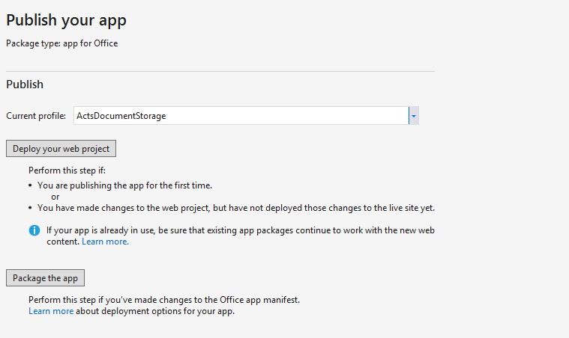

* **Verify Azure URL** and click finish.

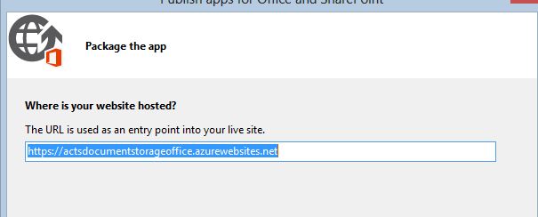

* After finishing the publish wizard, a directory will popped up and you can copy the manifest file.

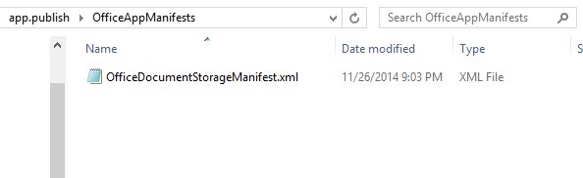

The second step includes uploading app manifest on office 2013.

A shared folder catalog provides a way to publish the manifests for task pane and content apps for Office to a network file share. Users can then acquire apps by specifying this file share as a trusted catalog, using the steps in the following procedure.

The manifest file is an XML file that enables you to declaratively describe how your app should be activated when an end user installs and uses it with Office documents and applications. See [Understanding the apps for Office XML manifest](http://msdn.microsoft.com/en-us/library/office/fp161044(v=office.15).aspx) for more information.

The manifest file is the only file that you should deploy to the shared folder catalog—you should deploy the web application itself to a web server, the URL of which you specify in the **SourceLocation** element of the manifest file.

|  |
| --- |
| **Important** |
| To help make apps that access external data and services more secure, your app should use a secure protocol such as Hypertext Transfer Protocol Secure (HTTPS) to connect to external data and services. |

### To specify a file share as a trusted catalog

1. Create a folder on a network share, for example \\MyShare\MyManifests.
2. Put the manifest files for the task pane and content apps that you want to publish in this file share.
3. Open a new document in Excel, Word, or PowerPoint.
4. Choose the **File** tab, and then choose **Options**.
5. Choose **Trust Center**, and then choose the **Trust Center Settings** button.
6. Choose **Trusted App Catalogs**.
7. In the **Catalog Url** box, enter the path to the network share you created in Step 1, and then choose **Add Catalog**.
8. Select the **Show in Menu** check box, and then choose **OK**.

After performing these steps, you can select **My Apps** on the **Insert** tab of the ribbon and then choose **Shared Folder** at the top of the **Apps for Office** dialog box to insert a task pane or content app from this catalog as shown in following Figure.

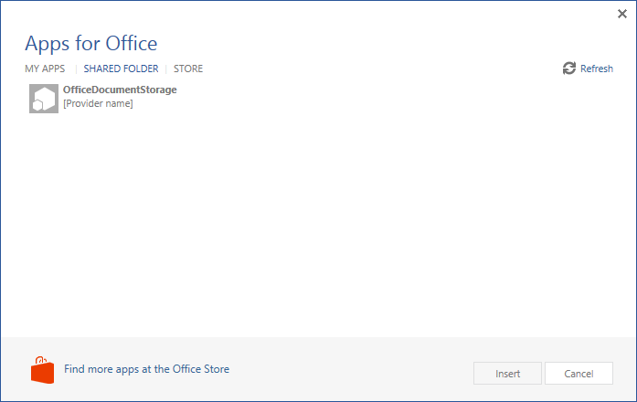

**Creating Accounts for Cloud Storage**

***Creating and Configuring Dropbox Account***

* Navigate to <https://www.dropbox.com/developers/apps> site.
* Click on the **Create App button**.

Machine generated alternative text:
Developer home 
App Console 
Browse datastores 
Your apps 
Create app 
The Dropbox Platform gives yau effortless access to hundreds of millions of Dropboxes. Whether you're building a server-based app 
with the Core API, syncing structured data with the Datastore API, or just grabbing files with the Chooser, you'll need to create an 
app to integrate with Dropbox. 
Support 
You haven't created any apps. 
Community 
O English A 
7:24 PM 
11/19/2014 
Drop-ins 
core API 
Datastore API 
sync API 
Webhooks 
Developer guide 
Branding guide 
Blog 
Support 
Drop box 
About us 

* Choose Dropbox API App.

Machine generated alternative text:
Create a new Dropbox Platform app 
What type of app do you want to create? 
Drop-ins app 
Chooser or Saver 
Dropbox API app 
Sync API, Datastore API, or Core API 

Choose following option to create new app.

Machine generated alternative text:
@ 
Files and datastores 
Datastores only 
Can your app be limited to its own folder? 
Yes 
— My app only needs access to files it creates. 
My app needs access to files already on Dropbox. 
What type of files does your app need access to? 
Specific file types — My app only needs access to certain file Vpes, like text or photos. 
@ All file types — My app needs access to a user's full Dropbox. Only supported via the Core API. 
Provide an app name, and you're on your way. 
ACTS Document Learning Demo 
Terms of Ser-vice 
91 agree to Dropbox API Terms and Conditions 

* After the app is created, next step is to configure the redirect URL. The code contains DropboxRedirect.html. You need to **add the Azure relative URL** for DropboxRedirect.html in redirect URL field.
* Keep note of Client ID and Client Secret which we will use to update the Azure Web configuration.

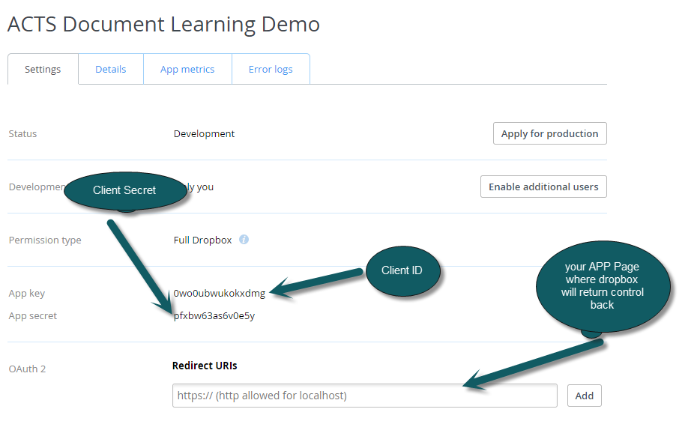

***Creating and Configuring the Google Drive Account***

* Navigate to <https://console.developers.google.com/project> site.
* Click on **Create Project** button.

Machine generated alternative text:
htt s://console.develo ers. oo le.com/ ro.e 
Developers Console 
You don't have any projects! 
ate a new project to get started. 
Create Project 

* Click on the **Create Project** button and it will open following screen to input project name.

Machine generated alternative text:
New Project 
PROJ CT NAME 
ACTS Demo For Document Storage 
PROJ CT ID 
formidable-deck-76g 
I have read and agree to all Terms of Service for the Google Cloud 
Platform products. 
Create 
Cancel 

* **Enable Drive API**

Machine generated alternative text:
Project Dashboard 
Boost your app with a Google API 
use Google APIs with your app to harness the power of 
Google's services and technologies 
Enable an API 
Try BigQuery with population data 
Run queries against huge public data sets to see how 
BigQuery can help you analyze your own data 
Try BigQuery 
Launch click-to-deploy software 
Deploy popular open stacks on Google Compute Engine 
just by filling out a simple form 
Try Click to Deploy 
Create a storage bucket 
Store your unstructured data safely and with high 
availability using Google Cloud Storage 
Create bucket 
Spin up a Compute Engine 
Get started with Google Con 
first VIVI instance 
Create instance 
Activities (Idle) 
Create Project: ACTS Demo For Document St 

Machine generated alternative text:
Enabled APIs 
Some APIs are enabled automatically. You can disable them if you're not using their services. 
NAME 
BigQuery API 
Drive API 
Google Cloud SQL 
Google Cloud Storage 
Google Cloud Storage JSON API 
QUOTA 
STATUS 

We will add Product Name on Consent Screen.

Machine generated alternative text:
Projects 
ACTS Demo For Do... 
Overview 
Permissions 
Billing & settings 
APIS & auth 
APIs 
Credentials 
Consent screen 
Push 
Monitoring 
Source Code 
Com pute 
Networking 
Storage 
Bia Data 
Consent screen 
The consent screen will be shown to users whenever you request access to their private data using your client ID. 
Note: This screen will be shown for all of your applications registered in this project 
EMAIL ADDRESS 
Choose your email 
PRODUCT NAME 
Product Name 
(Optional) 
HOMEPAGE URL 
PRODUCT LOGO (Optional) O 
This is how your logo will look to end users. 
Max size 120x120 PX 
@ 
your ba 
circles. 
Make you lisl 
via Google, vi 
Your circles 
By clicking 
accordance tne.r 
charge this and other 

Create new Client ID from the credentials screen.

Machine generated alternative text:
Projects 
ACTS Demo For Do... 
Overview 
Permissions 
Billing & settings 
APIS & auth 
APIs 
Credentials 
Consent screen 
Push 
Monitoring 
Source Code 
Com pute 
Networking 
Storage 
Big Data 
OAuth 
OAuth 2.0 allows users to share specific 
data with you (for example, contact lists) 
while keeping their usernames, passwords, 
and other information private. 
Learn more 
Create new Client ID 
Public API access 
use of this key does not require any user 
action or consent, does not grant access to 
any account information, and is not used 
for authorization. 
Learn more 
Create new Key 

From the screen below **choose the Web application** option.

Machine generated alternative text:
Create Client ID 
APP ICATION TYPE 
@ Web application 
Accessed by web browsers over a network 
Service account 
Calls Google APIs on behalf of your application instead of an end-user 
Learn more 
Installed application 
Runs on a desktop computer or handheld device (like Android or iPhone) 
AUTHORIZED JAVASCRIPT ORIGINS 
Cannot contain a wildcard (http:/ft_examplecom) or a path 
(http://example.com/subdir)_ 
https://www_example.com 
AUTHORIZED REDIRECT URIS 
One URI per line. Needs to have a protocol, no URL fragments, and no relative 
paths Cant be a non-private IP Address. 
https://www_example.com/oauth2callback 
Create Client ID 
Cancel 

* After creating Client ID, followings are the parameters we will use in development.
  1. Client ID
  2. Client Secret
  3. Redirect URL
* You can click on the Edit Setting to update the settings.
* After the app is created, next step is to configure the redirect URL. The code contains DriveRedirect.html. You need to add the Azure relative URL for DriveRedirect.html in redirect URL field.
* Keep note of Client ID and Client Secret which we will use to update the Azure Web configuration.

Machine generated alternative text:
Client ID for web application 
CLIENT ID 
EMAIL ADDRESS 
CLIENT SECRET 
REDIRECT URIS 
JAVASCRIPT ORIGINS 
292364202482-s30u6eOieqahgcnOss50htma8mcOvrro.apps.googleusercontent.com 
292364202482-s30u6eOieqahgcnOss50htma8mcOvrro@developer.gserviceaccount.com 
61151 5tuFN81EPxahpjxe64Nv 
https://"%'w.example.com/oauth2callback 
https://www.example.com 
Delete 
Edit settings 
Download JSON 
Reset secret 

***Creating and Configuring the One Drive Account***

* Login to the Azure management website.
* Choose the ***Active Directory Domain Services (AD DS)*** which is mapped to the OneDrive for Business.

Machine generated alternative text:
Admini 
4 
AUTOMATION 
SCHEDULER 
API MANAGEMENT 
MACHINE LEARNING 
NETWORKS 
TRAFFIC MANAGER 
MANAGEMR'T SERVICES 
ACTIVE DIRECTORY 
MARKETPLACE 
STORSIMPLE 
SETTINGS 
active 
DIRECTORY 
NAME 
directory 
ACCESS CONTROL NAMESPACES 
STATUS 
MULTI-FACTOR AUTH PROVIDERS 
RIGHTS MANAGEMENT 
ROLE 
Globa 
DATACENTER REGION 
u n ited States 
SUBSCRIPTION 
Shaæd by all ACTS 
COUNTRY OR REGI.„ 
united Stat% 
p 

* Go into the applications section, you must see the Office 365 Exchange and SharePoint Online applications already in the list. If you cannot find it, it means your **Azure** ***Active Directory Domain Services (AD DS)*** is not mapped with the OneDrive.

Machine generated alternative text:
ACT s 
web 
acts 
USERS 
NAME 
GROUPS 
APPLICATIONS 
DOMAINS 
DIRECTORY INTEGRATION 
CONFIGURE 
pplicaticn 
b appliation 
b appliation 
REPORTS 
LICENSES 
App U RL 
https://lo 
poi nt.' 
rporati o n 
rporati o n 
we 
we 
online 
PUBLISHER 
nft Co 
nft Co 
Offiæ BSS 
Offiæ Sharepoin 

* We need to create new Application in the **Azure** ***Active Directory Domain Services (AD DS)***.

Machine generated alternative text:
What do you want to do? 
@ Add an application my organization is developing 
@ Add an application from the gallery 

* This Screen will take OneDrive app name as input.

Machine generated alternative text:
ADD APPLICATION 
Tell us about your application 
NAME 
ActsLearning 
Type 
@WEB APPLICATION AND/OR WEB API 
O NATIVE CLIENT APPLICATION 

* In the following “App properties” screen:
  1. Sign-On URL will describe the landing page of your application where OneDrive will handover control back after authenticating the OneDrive through OAuth.
  2. App ID URI will describe any app name after your SharePoint tenant.

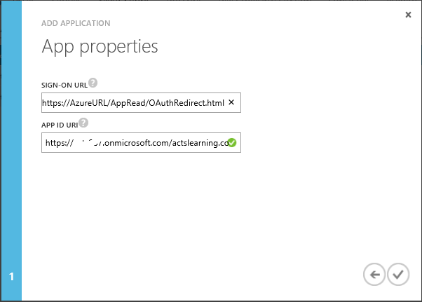

* After creating the app, there are few steps of configuration:
  1. Validate the “Sign On URL” and “Reply URL” to be pointing to the OAuthRedirect.html on Azure.
  2. Choose Yes for “Application is Multi-Tenant”.
  3. Create a key (Secret Key), which would be by default valid for one year (you can change it).
  4. Add the Client ID, and Client secret to the Office App Web in Azure.
  5. Give Delegate permission to the “Office 365 SharePoint online” and “Windows Azure *Active Directory Domain Services (AD DS)*”

Machine generated alternative text:
Acts i ng 
actslearning 
DASHBOARD USERS 
properties 
NAME 
SIGN-ON URL 
CONFIGURE 
OWNERS 
Office 
Office 
365 
365 shM-ePo_ 
ActsLearning 
httpsJ/IocaIhost44317/AppRead/OAuthRedirect.htmI 

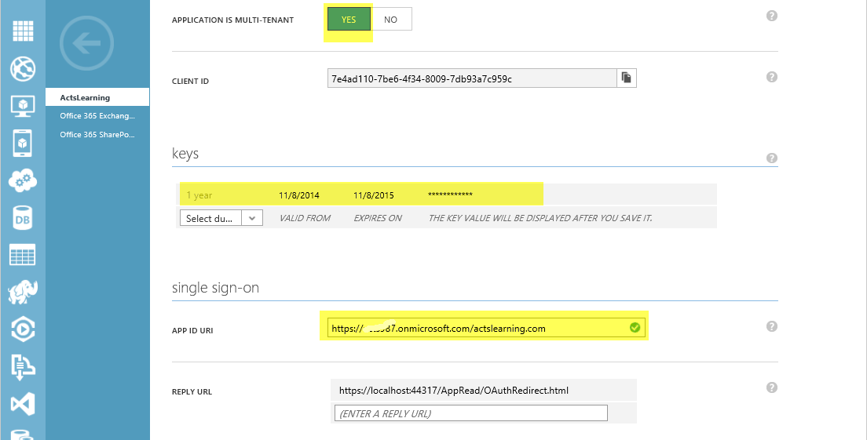

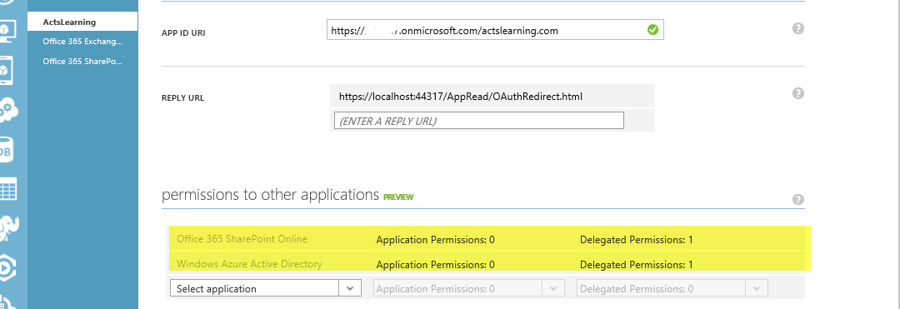

***Updating App Web Configuration***

After all this exercise, we have three Client ID and three Client secrets for Dropbox, OneDrive and Google Drive. The final Step is to update the Office App Configuration defined in Section [#Deploying App Web in the Azure](#_Deploying_App_Web) with these three Client ID and Client Secret.

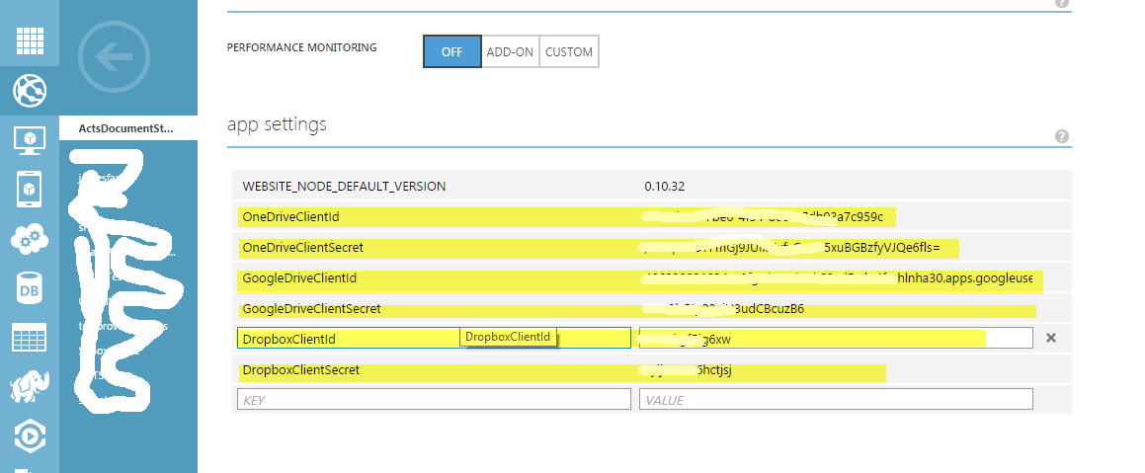

***Final Result***

Now that all deployment and configuration part is completed we can see the app in our Word/Excel/Power point application. There is an option to authenticate and upload attachment to cloud (OneDrive, Dropbox and Google Drive). Before uploading the document to any storage, it is required that you its particular authentication link first for the current session (Storage tokens are not stored in database which can be implemented as an extension to this application).

